Project Title: CineRate – A Backend Movie Review Database
Developed By: Ankit Gupta
Registration No.: 24BSA10200
Acknowledgement I would like to express my sincere gratitude to my mentors, faculty members, and everyone who provided guidance and support throughout the development of this project. Their valuable suggestions and encouragement helped me successfully complete this work. I am also thankful for the learning resources and documentation that enhanced my understanding of backend API development and MongoDB.
Executive Summary CineRate is a robust backend movie review system engineered to manage directors, movies, and user reviews. The system serves as a foundational API layer designed to facilitate seamless data interactions for a full-stack movie rating platform. By utilizing a NoSQL architecture, the project demonstrates efficient relational mapping and scalable backend logic.

Strategic Objectives and Technical Scope
Project Objectives
- Centralize the management of directors, movies, and reviews within a singular backend system.
- Execute full Create, Read, Update, and Delete (CRUD) operations for all entities.
- Implement One-to-Many data relationships through MongoDB references to ensure data integrity.
- Expose clean, RESTful API endpoints for efficient client-side interaction and automated testing.
Expected Outcome The project delivers a reliable and scalable platform that simplifies movie record management. It serves as a proof-of-concept for integrating routing, NoSQL databases, and relational structuring in a professional software environment. The architecture is future-proofed for potential integration with frontend frameworks like React.
Tools and Technologies
- Language: Java
- Framework: Spring Boot
- Database: MongoDB
- Testing: Postman, Swagger
- Version Control: Git & GitHub

Architectural Design and Core Modules
ScreenShots
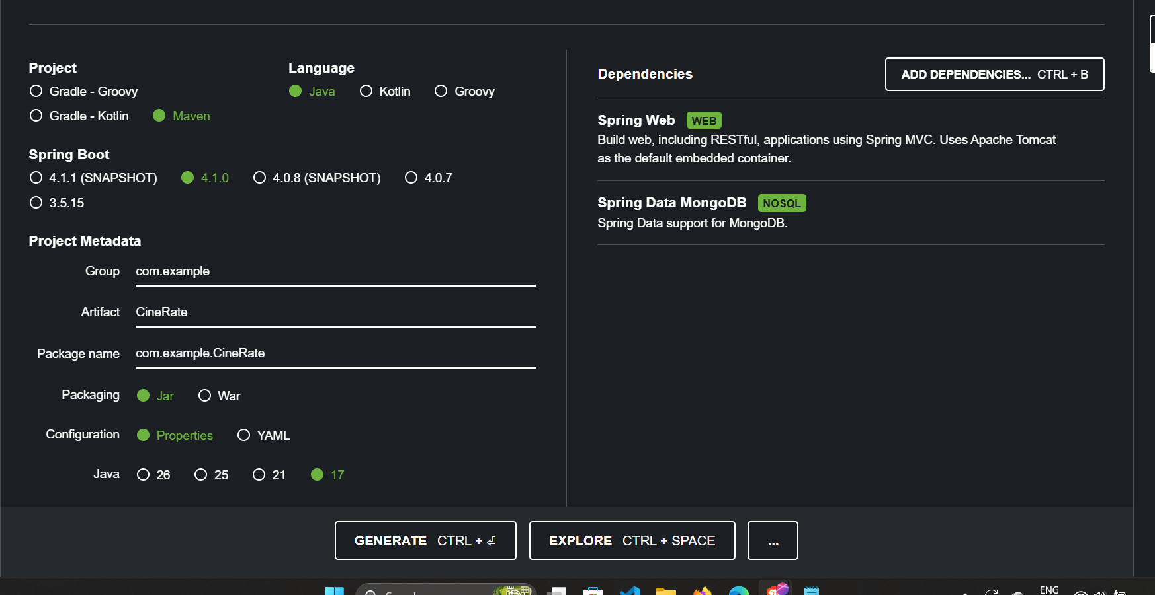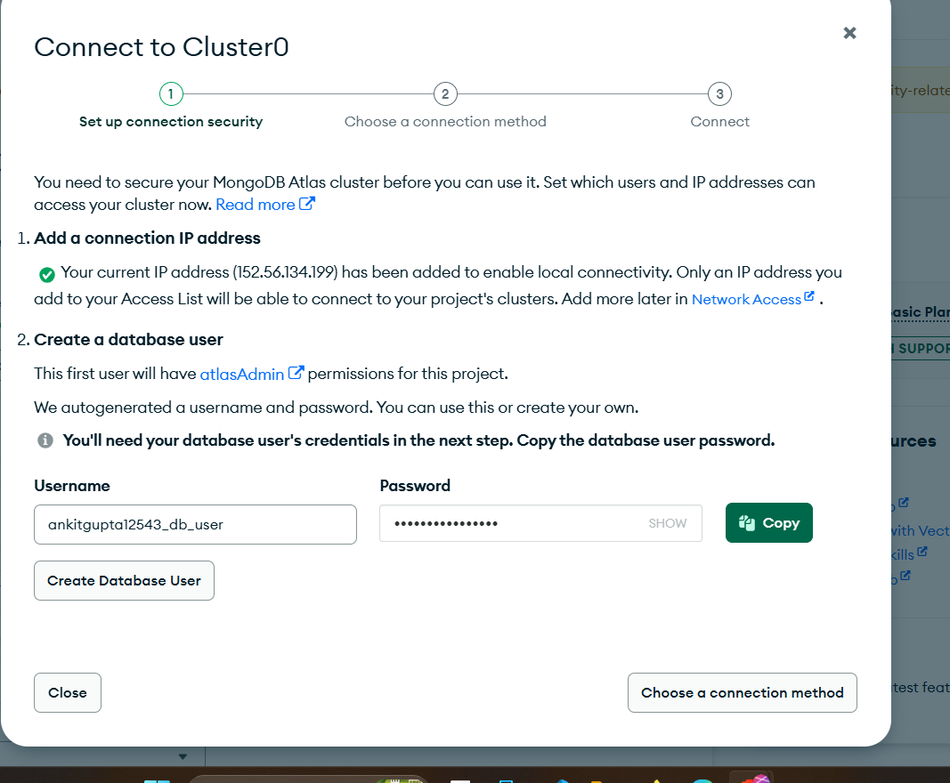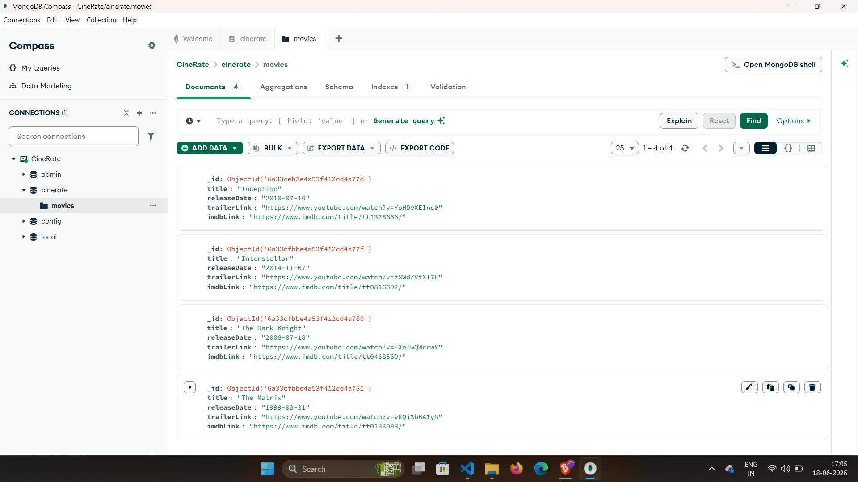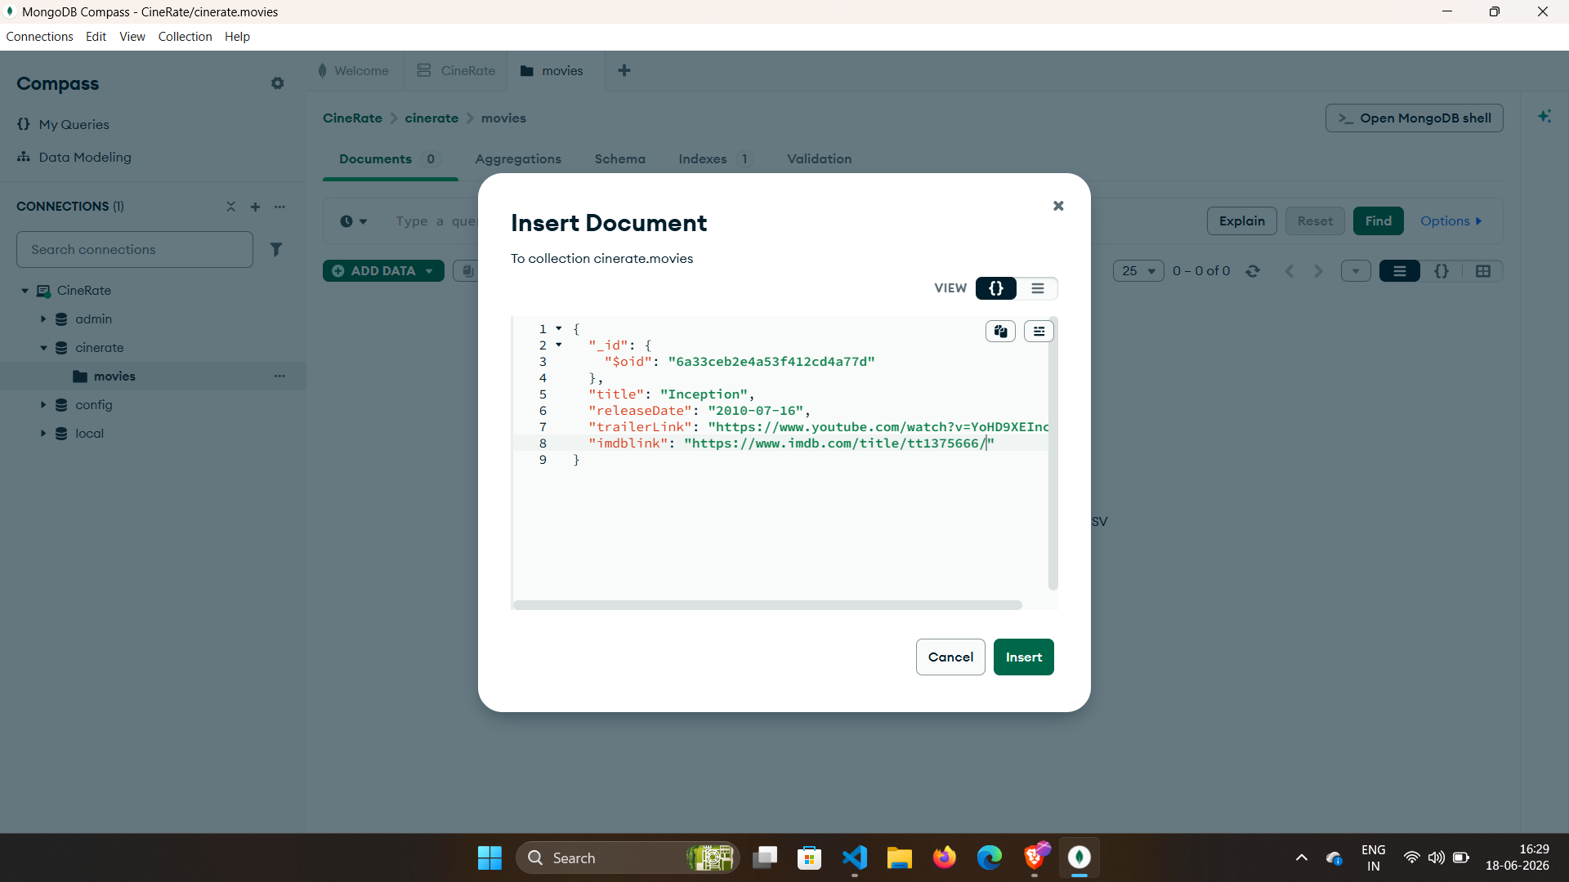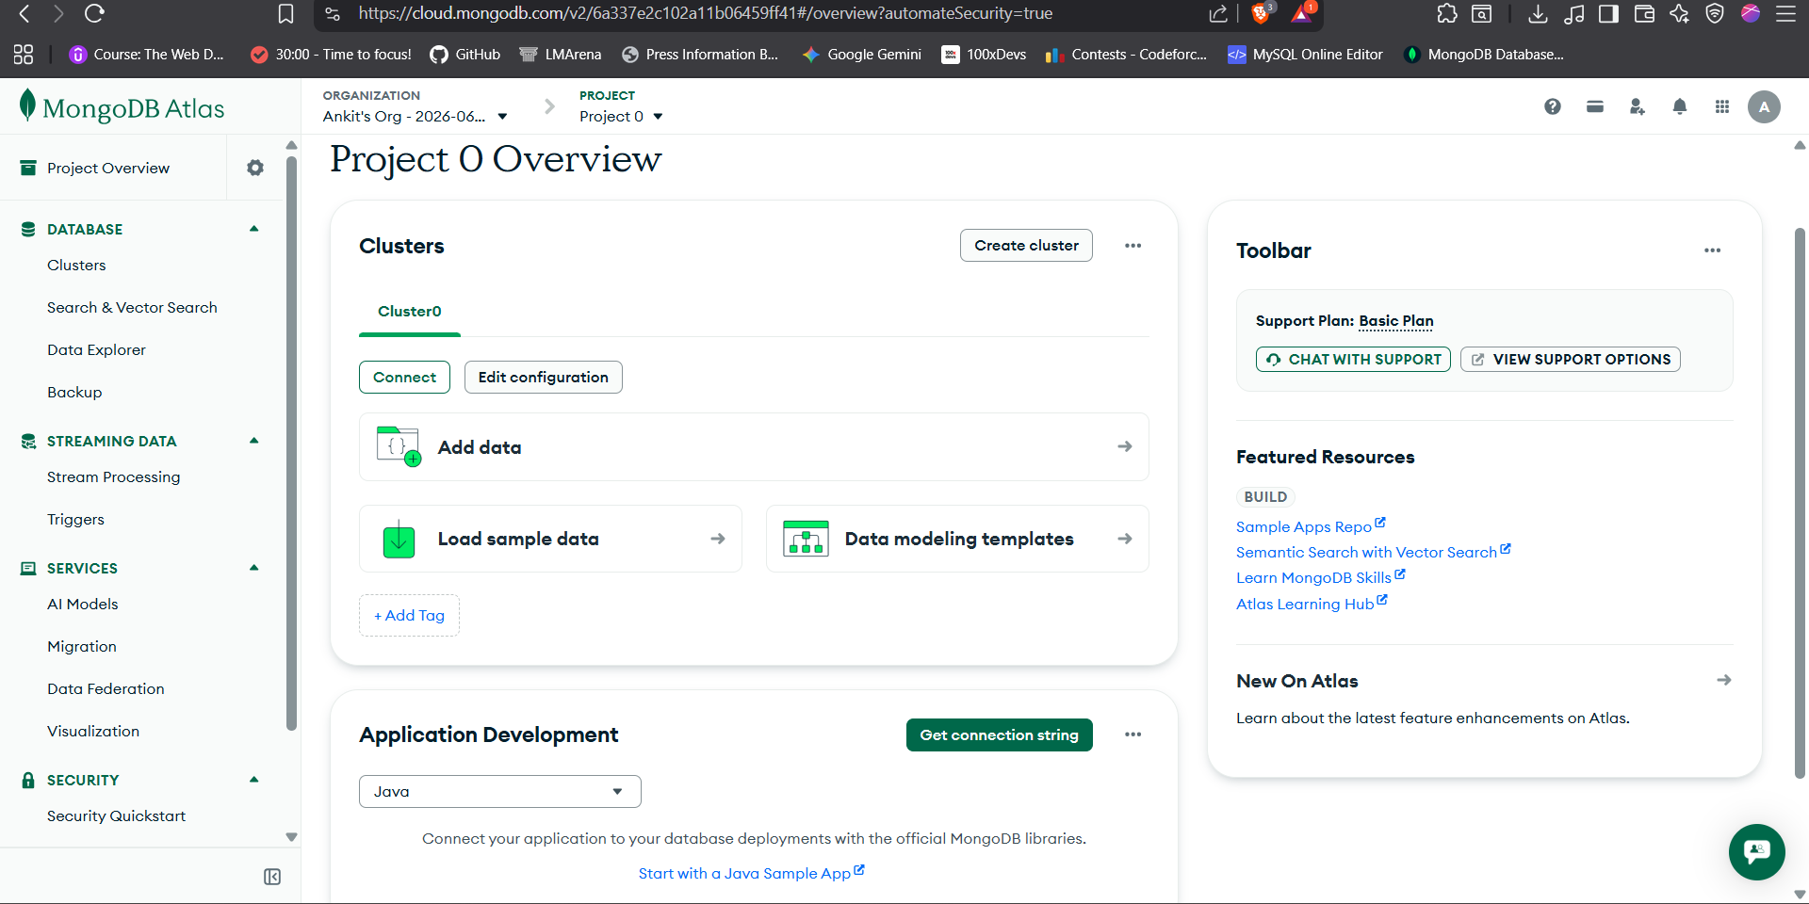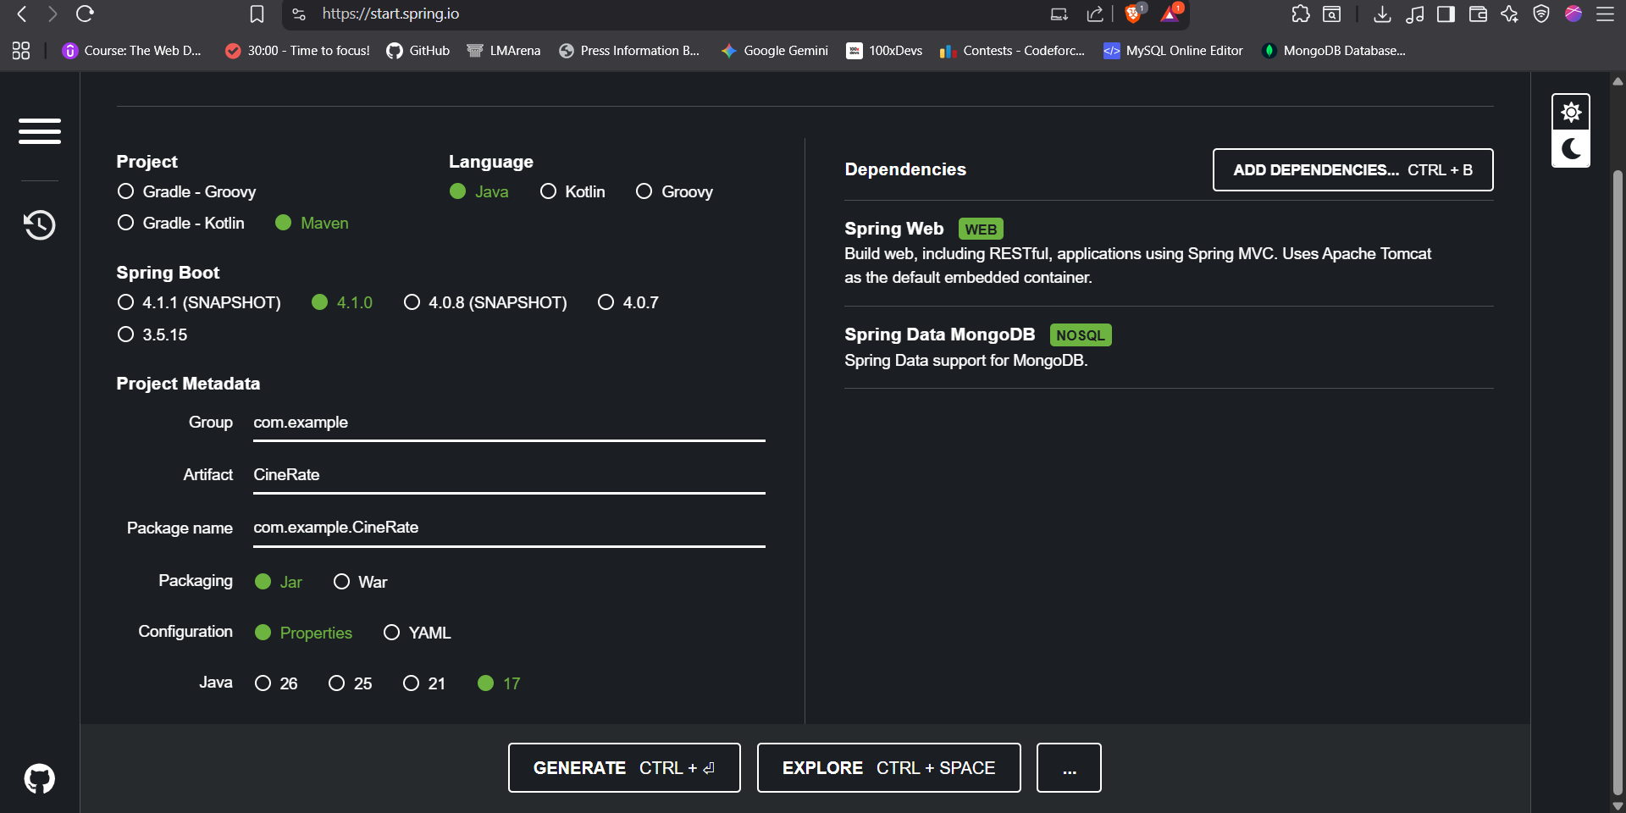

System Modules
- Director Management: Handles the metadata and association of directors to movies.
- Movie Management: Manages the core library of movie entries.
- Review Management: Facilitates the submission and retrieval of user-generated content.
Architectural Milestones
- Model Layer: Defined structured schemas for Movie and Review entities.
- Repository Layer: Utilized Spring Data MongoDB interfaces to streamline database interactions.
- Service Layer: Developed ReviewService logic to handle the dynamic insertion of reviews into existing movie arrays.
- Controller Layer: Mapped HTTP requests (/api/movies, /api/reviews) to business logic endpoints.
Implemented Features
- API Retrieval (GET): Provides efficient fetching of movie documents from the database.
- Review Submission (POST): Allows JSON payload submission, including review text and IMDB links.
- Dynamic Linking: Successfully establishes relationships between review objects and movie objects in real-time.

Troubleshooting and Final Status
Debugging & Problem Solving
- Component Scanning: Overcame 404 errors by restructuring the project to place the main application file in the root directory.
- Model Synchronization: Resolved a critical startup crash (lookupQuery error) by aligning the imdbLink variable in the Movie model with repository expectations.
- Database Configuration: Addressed environment caching issues that diverted traffic to the test database, ensuring the connection logic now correctly targets the cinerate database.
Conclusion and Future Potential The CineRate backend is fully functional and handles complex business logic and database interactions as intended. The codebase is robust, clean, and ready for further evolution. Future phases of development may include advanced user authentication, sophisticated validation rules, and the integration of a modern frontend interface.

